**Project Hub Bug Details (30-10-24):**

1. Kanban Board- Task type displayed empty value.
2. Kanban Board- After select Task type from dropdown, it should automatically closed.
3. Kanban Board- Extra arrow button present near Task Type.
4. Kanban Board-When click the kanban board in task management , details displayed empty values.
5. Kanban Board- When add task “In Progress” and other tabs details is continuously saved in first column “BackLog”.
6. Kanban Board- Multiple task type is able to select, is that a feature or bug?-Need confirmation from project lead.
7. Kanban Board-Column name should display full details. In Select for development full text is not displayed.
8. Kanban Board-First five column user cannot able to delete, so there no need for delete button for the five columns. Need to remove the delete button
9. Kanban Board- Create task and Edit task displayed different kind of pop up.
10. Kanban Board-Edit the task-When enter sub-task and click cancel button and again click the create task button, previous details are displayed.
11. Kanban Board-Edit the task-After save a sub-task, in that tab when click the Image icon, a unwanted pop up is displayed.

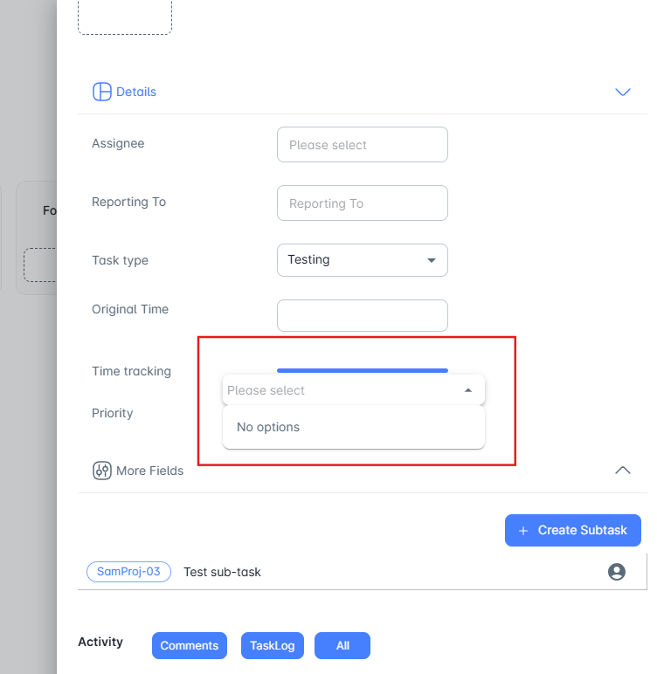

1. Kanban Board-Edit the task- After click task log button, no details is displayed and when click all button, task log detail is displayed. But when click all button both comments and task log detail should display.
2. Kanban Board-Edit the task- In Details tab arrow button display downward only.
3. Kanban Board-Edit the task- In more fields tab arrow button display upwards only.
4. Kanban Board-Edit the task- There is no save button for after modify the task details, save button only present for description.
5. Kanban Board-Edit the task-Time Tracking-Time select option AM should present in top and PM should present in bottom.
6. Kanban Board-Edit the task-Time Tracking-Change cancel option into clear option. Close button is already present so no need for cancel button.
7. Kanban Board-Edit the task-In details tab, Intially the assignee and reporting to dropdown details are empty. Once click the task name in top of the pop up, values are displayed.
8. Release-Empty details is displayed in the grid.
9. Release-After click add new button, automatically displayeed the error message in start and end date.
10. Release-Add/edit, after click clear button, start and end time is not cleared.